**Use Cases**

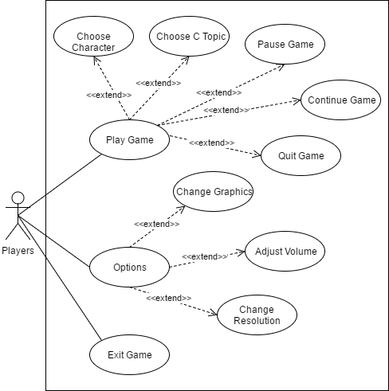

**Player Use Case List**

**UC1 Play Game:** Allows the player to play the game

**UC2 Options:** Allows the player to configure the audio, video and resolution settings of the game

**UC3 Exit Game:** The game will terminate

**UC4 Choose Character:** Allows the player to select character, either Male or Female

**UC5 Choose C Topic:** Allows the player to choose one topic out from 9 topics of C.

**UC6 Pause Game:** The game will temporary stop in action or pause the game.

**UC7 Continue Game:** The game will resume

**UC8 Quit Game:** The game terminates and will return to the main menu.

**UC9 Change Graphics:** Allows the player to adjust the game’s graphics

**UC10 Adjust Volume:** Allows the player to adjust the game’s volume

**UC11 Change Resolution:** Allows the player to adjust the window’s resolution of the game.

**Player Use Case Scenarios**

**Table 1. PLAY GAME**

|  |  |
| --- | --- |
| **U1:** Play Game | |
| **Pre-Condition:** | |
| **Actor’s Action** | **System Response** |
| 1. The user clicks the “Play Game” button | 1. System will display Choose Character scene |
| **Post-Condition:** Choose Character | |

**Table 2. OPTIONS**

|  |  |
| --- | --- |
| **U2:** Options | |
| **Pre-Condition:** | |
| **Actor’s Action** | **System Response** |
| 1. The user clicks the Option button | 1. System will display different Game Options |
| **Post-Condition:** System displays different options for the player to freely adjust | |

**Table 3. EXIT GAME**

|  |  |
| --- | --- |
| **U3:** Exit Game | |
| **Pre-Condition:** | |
| **Actor’s Action** | **System Response** |
| 1. The user clicks “Exit Game” button | 1. The game is terminated, directing the user into the home screen |
| **Post-Condition:** The game is terminated | |

**Table 4. CHOOSE CHARACTER**

|  |  |
| --- | --- |
| **U4:** Choose Character | |
| **Pre-Condition:** Choose C Topic | |
| **Actor’s Action** | **System Response** |
| 1. The user gets to select desired character | 1. Prologue scene loads |
| **Post-Condition:** Prologue scene loads | |

**Table 5. CHOOSE C TOPIC**

|  |  |
| --- | --- |
| **U5:** Choose C Topic | |
| **Pre-Condition:** The user clicks the Play Game button | |
| **Actor’s Action** | **System Response** |
| 1. The user gets to select desired C topic | 1. Game prepares to load the game world, loads Character selection screen |
| **Post-Condition:** User selects character | |

**Table 6. PAUSE GAME**

|  |  |
| --- | --- |
| **U6:** PAUSE GAME | |
| **Pre-Condition:** | |
| **Actor’s Action** | **System Response** |
| 1. The user presses the Enter button | 1. System pauses the game |
| **Post-Condition:** The system will stop the game from running in the background temporarily | |

**Table 7. CONTINUE GAME**

|  |  |
| --- | --- |
| **U7:** Continue Game | |
| **Pre-Condition:** Player presses the “Enter” button to pause | |
| **Actor’s Action** | **System Response** |
| 1. Player clicks “Continue Game” | 1. Game will resume |
| **Post-Condition:** Game will continue | |

**Table 8. QUIT GAME**

|  |  |
| --- | --- |
| **U8:** Quit Game | |
| **Pre-Condition:** Player presses “Enter” button to pause | |
| **Actor’s Action** | **System Response** |
| 1. Player clicks “Quit Game” button | 1. System will quit the game |
| **Post-Condition:** Return to Main Menu Screen | |

**Table 9. CHANGE GRAPHICS**

|  |  |
| --- | --- |
| **U9:** Change Graphics | |
| **Pre-Condition:** Player clicks Option button on Main Menu screen | |
| **Actor’s Action** | **System Response** |
| 1. Player clicks “Adjust Graphics” button | 1. System adjusts graphics to user’s biddings |
| **Post-Condition:** | |

**Table 10. ADJUST VOLUME**

|  |  |
| --- | --- |
| **U10:** Adjust Volume | |
| **Pre-Condition:** Player clicks Option button on Main Menu screen | |
| **Actor’s Action** | **System Response** |
| 1. Player adjusts volume | 1. System adjusts game’s volume to user’s biddings |
| **Post-Condition:** | |

**Table 11. CHANGE RESOLUTION**

|  |  |
| --- | --- |
| **U11:** Change Resolution | |
| **Pre-Condition:** Player clicks Option button on Main Menu screen | |
| **Actor’s Action** | **System Response** |
| 1. Player changes resolution | 1. System adjusts game’s resolution to user’s biddings |
| **Post-Condition:** | |